**Exploring World Happiness Report and the Economic Freedom Index Using Python**

There are 195 countries in the world officially recognized by the UN. While an unspecified number of them are relatively consistent to maintain and develop their diverse economies, outstanding healthcare, and lack of corruption, the others are stuck in the state of political turmoil, deficient infrastructure and severe poverty. And, of course, there are countries that are somewhere in between.

These factors of politics, economy, quality of life inevitably affect citizens' overall happiness. To determine that United Nations Sustainable Development Solutions Network publicized the first [World Happiness Report](https://en.wikipedia.org/wiki/World_Happiness_Report#History) in 2012. The results are measured annually by calculating the numbers for:

* Social support
* Freedom
* Generosity
* GDP per capita
* Healthy life expectancy

The annual report along with the [Index of Economic Freedom](https://en.wikipedia.org/wiki/Index_of_Economic_Freedom) helps us correlate the happiness level of citizens with the explanation of the economic state in their respective countries. The categories here are:

* Property Rights
* Judical Effectiveness
* Government Integrity
* Tax Burden
* Government Spending
* Fiscal Health
* Business Freedom
* Labor Freedom
* Monetary Freedom
* Trade Freedom
* Investment Freedom
* Financial Freedom
* Tariff rate (%)
* Income Tax Rate(%)
* Corporate Tax Rate(%)
* Tax Burden % of GDP
* Government Expenditure of GDP
* Population
* GDP
* GDP Growth Rate
* 5 Year GDP Growth Rate
* GDP Per Capita (PPP)
* Unemployment
* Inflation
* FDI Inflow
* Public Debt

**The Data**

The most recent [World Happiness Report](https://www.kaggle.com/PromptCloudHQ/world-happiness-report-2019) measured with the Cantril ladder method is completed by surveying the respondents and asking them to evaluate their current lives on a scale of 0 to 10 (10 being the highest value). [Index of Economic Freedom](https://www.kaggle.com/lewisduncan93/the-economic-freedom-index#economic_freedom_index2019_data.csv) is used to track the elevation in categories such as property rights, fiscal health, monetary freedom, unemployment and so on.

Of  course, it is a very broad topic with much more information that can go into it. However, it is still interesting to analyze these countries to become more educated about the world, mentality, and economy. And hopefully, this analysis can inspire its readers to support non-profit organizations that work tirelessly to help people who live in the countries that are much less privileged than ours.

**0 - Getting Started**

I started by importing my first dataset from Kaggle into the [Jupyter](https://jupyter.org/). This is a pretty large dataset with 155 countries ranked from 1 to 155 measuring the happiness of people. We can see the list of countries using:

[https://1.bp.blogspot.com/-6NVpDduXSSI/XUtwjusrI6I/AAAAAAAADXA/27tn1BRk4AAewmi-jJwVx5IICIC2TjYwwCLcBGAs/s320/Screen%2BShot%2B2019-08-07%2Bat%2B8.44.30%2BPM.png](https://1.bp.blogspot.com/-6NVpDduXSSI/XUtwjusrI6I/AAAAAAAADXA/27tn1BRk4AAewmi-jJwVx5IICIC2TjYwwCLcBGAs/s1600/Screen%2BShot%2B2019-08-07%2Bat%2B8.44.30%2BPM.png)

Then we print:

[https://1.bp.blogspot.com/-1VjvAGU6XBs/XUtyOe2o6RI/AAAAAAAADXU/iO4FuZkkgdk_Czi9tcAcgbfzvN7XKdavwCLcBGAs/s1600/Screen%2BShot%2B2019-08-07%2Bat%2B8.51.58%2BPM.png](https://1.bp.blogspot.com/-1VjvAGU6XBs/XUtyOe2o6RI/AAAAAAAADXU/iO4FuZkkgdk_Czi9tcAcgbfzvN7XKdavwCLcBGAs/s1600/Screen%2BShot%2B2019-08-07%2Bat%2B8.51.58%2BPM.png)

to analyze the categories that were used to measure the level of life satisfaction.

Just to have a general idea of the happiest countries in the world we can type **df.head(5)** and go over the top 5 countries on the ranker. We can see that Finland is the happiest country on Earth according to this report. An entertaining fact: Finland takes home the gold medal for two years in a row.

**0.0 - Analyze the top 5 countries**

What do Finland, Denmark, Norway, Netherlands, and Switzerland have in common (other than the weather)?

**0.1 - Ranking, GDP, Health**

People in the top 5 countries pay incredibly [high taxes](https://www.cnbc.com/2017/08/09/the-happiest-countries-in-the-world-also-pay-a-lot-in-taxes.html), and do so happily. In exchange, they pay 0 out-of-pocket for healthcare, receive free education, and long paid vacations. They also have strong social foundations and trust in the government.

To check whether this information is credible we can simply analyze the top 5 countries on our report using Matplotlib. I created a list with the top 5 countries that are Finland, Denmark, Norway, Netherlands, and Switzerland and created 3 lists with their respective numbers for their ranking, log of GDP per capita, and healthy life expectancy.

[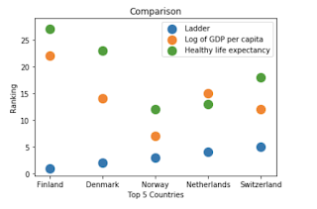](https://1.bp.blogspot.com/-OuipB8c0YuA/XUt2Au950NI/AAAAAAAADXg/5SS3Ae7AAqUsGSbXLYbFxUZPP2VxSCiKwCLcBGAs/s1600/Screen%2BShot%2B2019-08-07%2Bat%2B9.08.08%2BPM.png)

**0.2 - Immigration, Freedom, Corruption, and Social Support**

I was inspired to create this particular set because my question for this data analysis is how does immigration affect the happiness level in these countries? Fortunately, I stumbled upon this interesting article to answer my [question](https://www.telegraph.co.uk/business/2018/03/14/immigration-does-not-make-local-people-less-happy-world-happiness/). According to it, Iceland and New Zealand, being in the top list of welcoming migrants have also made the top 10 in the World Happiness Report.

This ties into social support and freedom. How much do people in these countries value their communities? Do they think that their freedom is affected by the overwhelming number of immigrants moving to their countries?

[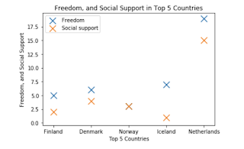](https://1.bp.blogspot.com/-SATPcUdU2rE/XUt77Ftx6CI/AAAAAAAADXs/KKkbpzeJQhwdoFM60JxXuBuhDkGEFNragCLcBGAs/s1600/Screen%2BShot%2B2019-08-07%2Bat%2B9.33.19%2BPM.png)

This analyzation helped me clarify the questions above. Most of the numbers in this category are similar. The exception is Netherlands with 19 and 15 in freedom and social support. This is not to doubt the place of Netherlands in the top 5, but simply to state that it visibly stands out in this graph.

**1.0 - Turkey**

In this section I will analyze Turkey's place in the World Happiness Report using a Python dictionary and a bar graph.

[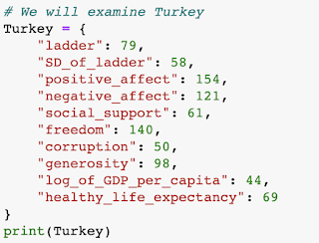](https://1.bp.blogspot.com/-IlBznTR6edg/XUt9Ud6bdJI/AAAAAAAADX4/yDs7WZImXzEEOvbf8e8y7NwI0oalEyVMACLcBGAs/s1600/Screen%2BShot%2B2019-08-07%2Bat%2B9.39.19%2BPM.png)

This will give us a nice output of the numbers for Turkey.

{'ladder': 79, 'SD_of_ladder': 58, 'positive_affect': 154, 'negative_affect': 121, 'social_support': 61, 'freedom': 140, 'corruption': 50, 'generosity': 98, 'log_of_GDP_per_capita': 44, 'healthy_life_expectancy': 69}

[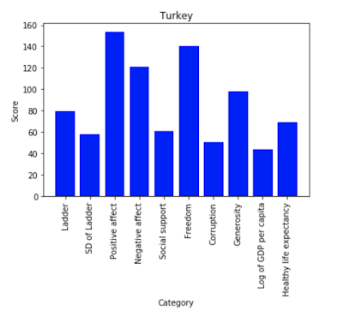](https://1.bp.blogspot.com/-FfaodfUNVJI/XUt-SWiuo-I/AAAAAAAADYI/o7HgV62TOP8nR98CPvs9_9s-RgnLiDafACLcBGAs/s1600/Screen%2BShot%2B2019-08-07%2Bat%2B9.43.23%2BPM.png)

I chose Turkey because I was interested in its numbers since it is one of the culture-wise closest countries to my home country [Azerbaijan](https://en.wikipedia.org/wiki/Azerbaijan).

**1.1 - Azerbaijan**

Next up is Azerbaijan which is on the 90th place. I used the exact same method that I did with Turkey to analyze this piece of data.

Here is the result described in a bar graph:

[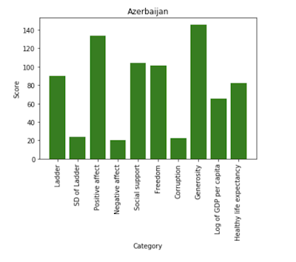](https://1.bp.blogspot.com/-0ptrLZ-1cOk/XUt_4rABt_I/AAAAAAAADYU/XjV1oWk29GcbxrJuUUhPR8YhE0p9FhlaQCLcBGAs/s1600/Screen%2BShot%2B2019-08-07%2Bat%2B9.49.52%2BPM.png)

**2.0 - Incorporating Economic Freedom Index**

I will be using pandas with this dataset. To install pandas simply enter pip install pandas in the terminal. Next up, type

[https://1.bp.blogspot.com/-RVjbsIu5Ib4/XUu0N2d9KZI/AAAAAAAADYk/cdXoldl5tRALnClGvV9L8pp3aa1R-KkAwCLcBGAs/s320/Screen%2BShot%2B2019-08-08%2Bat%2B1.33.33%2BAM.png](https://1.bp.blogspot.com/-RVjbsIu5Ib4/XUu0N2d9KZI/AAAAAAAADYk/cdXoldl5tRALnClGvV9L8pp3aa1R-KkAwCLcBGAs/s1600/Screen%2BShot%2B2019-08-08%2Bat%2B1.33.33%2BAM.png)

and upload my dataset.

[https://1.bp.blogspot.com/-pntLd9hAuyg/XUu0eJIVofI/AAAAAAAADYs/af1u33Pkx74vePpaFnkM50KrQnE95TLegCLcBGAs/s640/Screen%2BShot%2B2019-08-08%2Bat%2B1.34.30%2BAM.png](https://1.bp.blogspot.com/-pntLd9hAuyg/XUu0eJIVofI/AAAAAAAADYs/af1u33Pkx74vePpaFnkM50KrQnE95TLegCLcBGAs/s1600/Screen%2BShot%2B2019-08-08%2Bat%2B1.34.30%2BAM.png)

Actually, I was stuck on this step because my code wouldn't run without encoding="ISO-8859-1". But thankfully, it did the trick.

Now, let's get a quick preview of this dataset by using the traditional df.head().

**2.1 - Categories**

I briefly mentioned the categories in our dataset in the beginning, but just as a reminder we can check them by typing df.columns and it will show us the categories used for this data.

[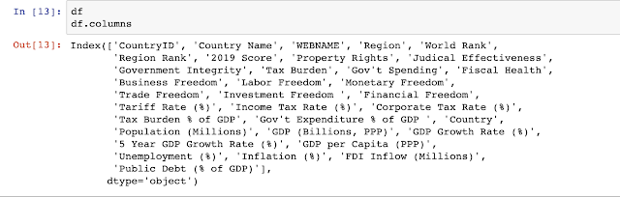](https://1.bp.blogspot.com/-wAsOTqaJiAs/XUu21l88naI/AAAAAAAADY4/WZoN3XnwugkhWUPiUqZz8i2tjwh_8KxIgCLcBGAs/s1600/Screen%2BShot%2B2019-08-08%2Bat%2B1.44.39%2BAM.png)

**2.2 - Negative GDP in the next 5 years**

Certain countries in our dataset will have a increase rate in their GDP. A few of them will conversely experience a decline. By running the function below we can see what countries will experience the decline.

[https://1.bp.blogspot.com/-R1GDgeAumWU/XUzwF_QWW1I/AAAAAAAADZI/WuenAO7UteIZKYrBX00pmSFd3kx3fjHcgCLcBGAs/s320/Screen%2BShot%2B2019-08-09%2Bat%2B12.01.16%2BAM.png](https://1.bp.blogspot.com/-R1GDgeAumWU/XUzwF_QWW1I/AAAAAAAADZI/WuenAO7UteIZKYrBX00pmSFd3kx3fjHcgCLcBGAs/s1600/Screen%2BShot%2B2019-08-09%2Bat%2B12.01.16%2BAM.png)

Bahamas, Belarus, Brazil, Brunei Darussalam, CAR, Equatorial Guinea, Greece, Kuwait, Libya, Macau, Suriname, Trinidad and Tobago, Ukraine, Venezuela and Yemen are among those countries.

**3- Conclusion**

The world is a big place with many events going on simultaneously. Unfortunately, some of those events include wars, strikes, and crimes. These events affect the people living in these countries financially and mentally.

The data in this project can be used to do a lot more. Including but not limited to:

* Create a sense of urgency to help prevent [hunger](https://www.actionagainsthunger.org/donate/save-lives-end-hunger), [proverty](https://donate.poverty-action.org/give/192232/#!/donation/checkout), [health](https://www.againstmalaria.com/Donation.aspx?GroupID=84) and many more.
* Create a game app for children to educate global awareness early on while doing it in a fun way.
* Create your own data analysis/ blogpost.

Thank you for making it this far. Feel free to share, comment with questions and criticisms.